

**Project Initialization and Planning Phase**

|  |  |
| --- | --- |
| Date | 15 March 2024 |
| Team ID | 739675 |
| Project Name | Cleantech: Transforming Waste Management With Transfer Learning |
| Maximum Marks | 3 Marks |

**Define Problem Statements (Customer Problem Statement ):**

Municipalities and waste management companies face challenges in accurately identifying, sorting, and classifying different types of waste due to the variability in waste appearance, contamination, and the limitations of traditional image recognition systems. This leads to inefficiencies, increased landfill use, and missed recycling opportunities. There is a need for an automated, intelligent, and adaptable deep learning-based system leveraging transfer learning to improve waste classification accuracy, optimize recycling processes, and support sustainable waste management practices.

 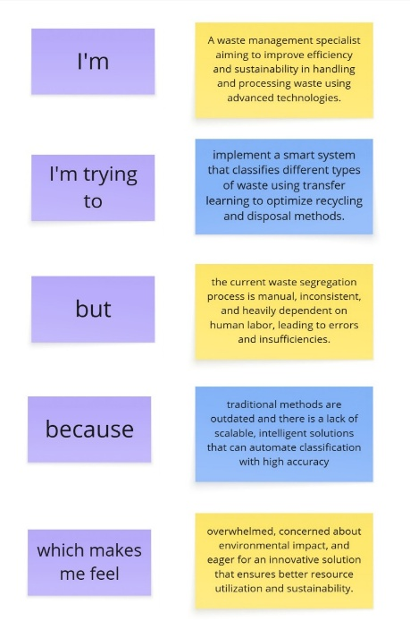

**Example:**

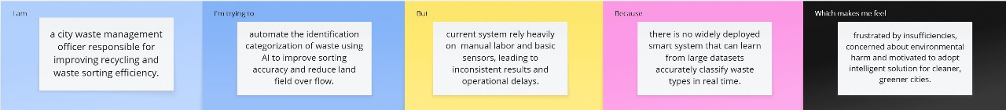



|  |  |  |  |  |  |
| --- | --- | --- | --- | --- | --- |
| **Problem**  **Statement**  **(PS)** | **I am** | **I’m trying to** | **But** | **Because** | **Which makes me feel** |
| PS-1 | a waste plant operator responsible for managing daily waste segregation and recycling operations. | increase the speed and accuracy of waste sorting to improve recycling rates | manual sorting is slow, tiring, and often leads to misclassification | there is no intelligent system that can assist workers | exhausted, under pressure, and concerned about not meeting sustainability goals. |
| PS-2 | an environmental policy maker focused on promoting cleaner cities | implement smart technology in waste systems to support eco-friendly policies | current systems lack advanced tools for accurate waste classification. | there is limited adoption of AI-based solutions like transfer learning | frustrated by slow progress, worried about the growing waste problem, and eager for smarter, scalable solutions. |